**PJ 6 Report Your Name: Francisco Valadez**

**A. The following is my Java program:**

**// Please copy your Java program into here from your Eclipse window. The code must be colored.**

**// You must not copy Java program from your .java file since the code over there is not colored at all.**

**// You must not show screen prints here.**

// Author: Francisco Valadez  
// Date: 5/27/2021  
// Purpose: This program checks if the string inputted by the user is a palindrome!  
  
import java.util.Scanner;  
  
public class Palindrome   
{  
 // reverses the word in order to compare it to the original input  
 public static String reverse(String word)  
 {  
 String reverseNum = "";  
   
 for(int i = word.length() - 1; i != -1; i--)  
 {  
 reverseNum += word.charAt(i);  
 }  
   
 return reverseNum;  
 }  
   
 // Return true if number is a palindrome  
 public static boolean isPalindrome(String word)  
 {  
 //sends the number to be reveresed and then is compared to see if its the same  
 if (reverse(word).equals(word))  
 return true;  
 else   
 return false;  
 }  
  
 public static void main(String[] args)  
 {  
 String word;  
 int counter = 1;  
   
 Scanner input = new Scanner(System.in);  
 System.out.println("Welcome to the Palindrome Game of Francisco Valadez!");  
 System.out.println(counter + "=====================================");  
 System.out.print("Please enter a word (@ to quit) >");  
 word = input.next();  
   
 while(word.equals("@") != true)  
 {  
 ++counter;  
   
 //sends the user's number to be checked if its a palindrome  
 if(isPalindrome(word) == true)  
 System.out.println("The word \"" + word + "\" is a palindrome");  
 else  
 System.out.println("The word \"" + word + "\" is NOT a palindrome");  
   
 System.out.println(counter + "=====================================");  
 System.out.print("Please enter a word (@ to quit) > ");  
 word = input.next();  
 }  
   
 System.out.println("Thank you for playing this Palindrome game of Francisco Valadez!");  
 System.out.println(counter + 1 + "=====================================");  
 }   
}

**B. The following is the complete output of my 3 test cases: [You must show 3 test cases.]**

**// Please copy your Eclipse console output into here.**

**Test Case 1:**

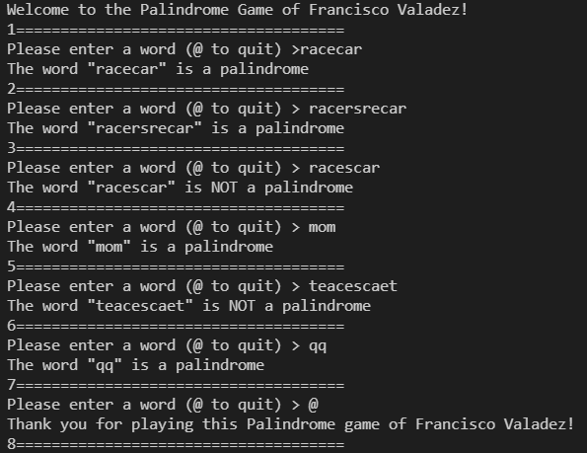

**Test Case 2:**

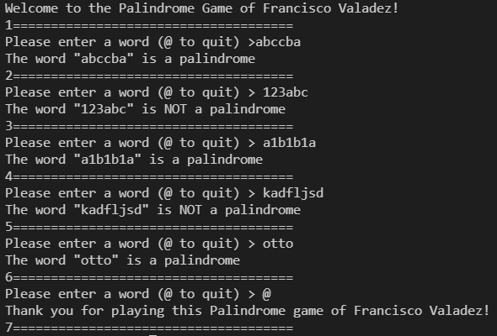

**Test Case 3:**

